SALFORD AIR QUALITY MONITORING PROJECT

CONTENT PAGE
- INTRODUCTION…………………………………………………………..1

- ANALYTICAL FINDINGS…………………………………………………3

- LIMITATION OF STUDY…………………………………………………11

- RECOMMENDATION……………………………………………………12

- FOLLOW ON STUDY…………………………………………………….14

INTRODUCTION
This report contains the analyses and analytical findings of the Salford air quality data taken across the 10 sampling points of the school.
The main aim of this report is to understand PM2.5 and it variables activities in these picked locations
Below is an explanation of PM2.5 and other analyzed variables and how its influenced by its variables:
What is PM2.5?
PM2.5 refers to Atmospheric Particulate Matter (PM) that has a diameter of less than 2.5 micrometers. To put this in perspective, a single human hair is about 50 to 70 micrometers in diameter, meaning PM2.5 particles are about 30 times smaller than the width of a hair.
Because they are so small, these particles are considered the most dangerous type of air pollution. Unlike larger dust, they can bypass the nose and throat, travel deep into the lungs (the alveolar region), and even enter the bloodstream, causing respiratory and cardiovascular diseases.
Common Sources of PM2.5
- Combustion Engines: Exhaust from cars, trucks, and buses (especially diesel engines).
- Industrial Activity: Power plants and manufacturing facilities.
- Biomass Burning: Wood-burning stoves, fireplaces, and agricultural burning.
- Secondary Formation: Chemical reactions in the atmosphere between gases like sulfur dioxide and nitrogen oxides (often from traffic).

Meaning of PM2.5 and it Related Variables and how its Influenced by them:
- PM10 (Coarse Particles)
Meaning: Particles with a diameter of less than 10 micrometers. PM10 includes PM2.5 as well as larger particles like dust, pollen, and mold.
Influence: PM10 and PM2.5 usually move together (they are highly correlated). If PM10 is high, PM2.5 is often high because they frequently share the same source, such as road dust or construction. A high ratio of PM2.5 to PM10 typically indicates that the pollution is coming from combustion (traffic/engines) rather than just mechanical dust

- Humidity (%RH)
Meaning: The amount of water vapor present in the air.
Influence: Humidity has a complex relationship with PM2.5 In high humidity, some particles absorb water and grow in size (hygroscopic growth), which can change how sensors detect them. Conversely, very high humidity or light rain can wash particles out of the air (wet deposition), temporarily lowering PM2.5 levels.

- Temperature
Meaning: The measure of heat in the atmosphere.
Influence: In colder weather, a temperature inversion can occur where warm air traps cold air (and pollutants) near the ground, causing PM2.5 levels to spike. In warmer weather, air tends to rise and circulate more, which helps disperse PM2.5 particles, often leading to lower concentrations at ground level.

- Co2 (Carbon Dioxide)
Meaning: A colorless gas produced by burning carbon and organic compounds and by respiration.
Influence: While Co2 is not a particle, it serves as a proxy for human activity and ventilation. If you find high Co2 and high PM2.5 together, it strongly suggests a lack of ventilation or a nearby combustion source (like a running engine or a crowded indoor space).

ANALYTICAL FINDINGS
OVERVIEW:
The dataset contains 15 rows for each of the 10 sampling point which makes it 150 observed rows all together for each of the monitoring device

We observed the data generated by the 2 monitoring device separately, where the first is AIRING-2000 series and the other was M2000 series
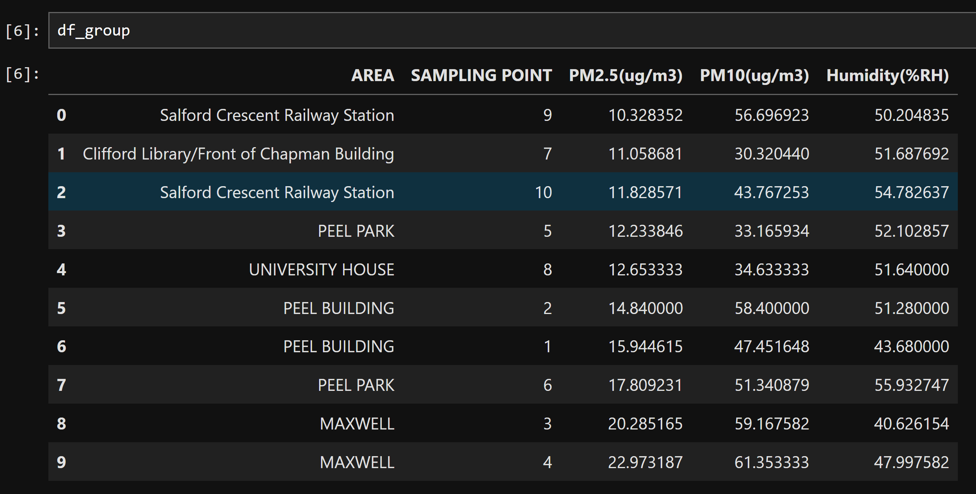
(AIRING-2000Monitoring Series grouped datapoint by location)
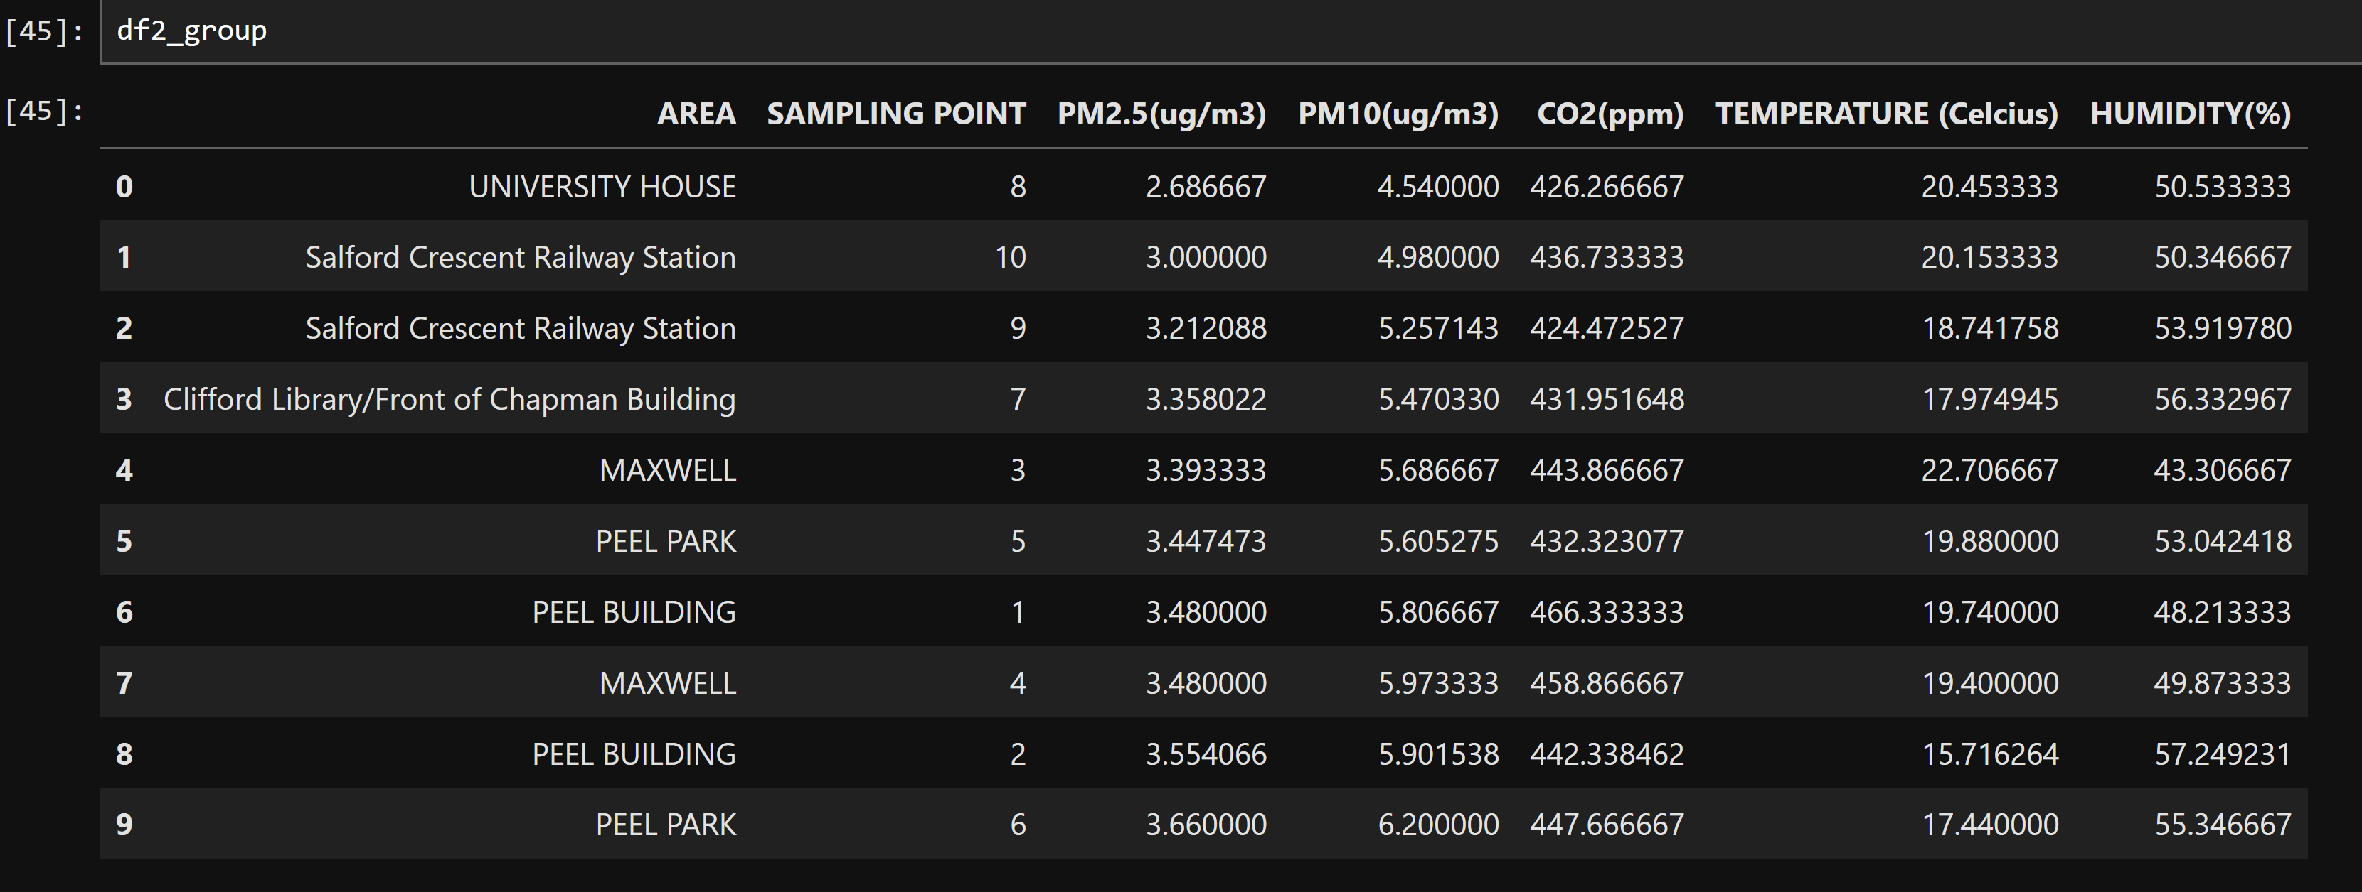
(M2000 Monitoring Series grouped datapoint by location)

Sampling Unit PM2.5 Intensity: For efficient comparison with the WHO stated (5 ug/m3), EU current healthy threshold of (20 ug/m3) and future (10 ug/m3), we grouped the dataset by location and plotted a bar chart to know at risk or safe zones in the observed environments:
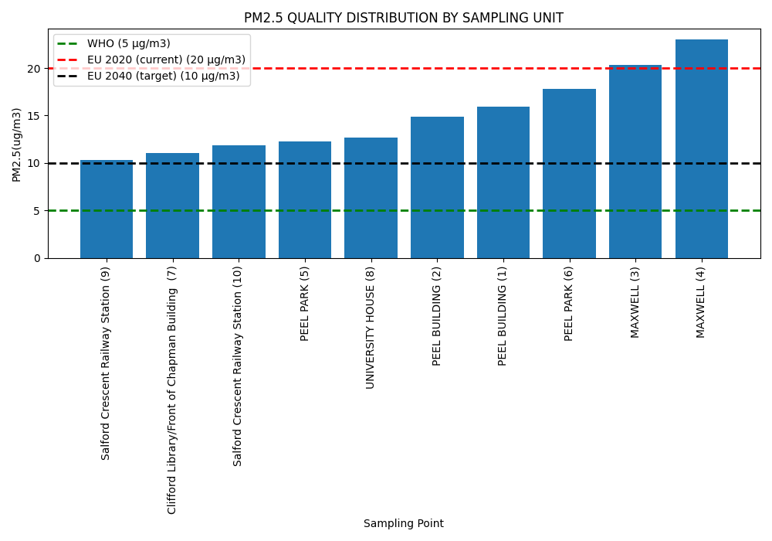
The analysis identifies Maxwell 3 and 4 as the two primary high-alert locations. Recorded levels at these sites exceed the WHO guidelines, the proposed EU 2040 standards, and the current EU threshold of 20 ug/m3. These elevated readings suggest close proximity to primary emission sources or a high concentration of PM2.5 within these micro environments. While the other locations are below the current set EU guidelines, it PM2.5 readings still surpass the WHO current guidelines and EU 2040 proposed guidelines.

- PM 2.5 and PM10 Relationship Plots:
To further understand the relationship of these PM2.5 readings, we examined it relationship of the 150 ungrouped rows of data to understand what drives the activity
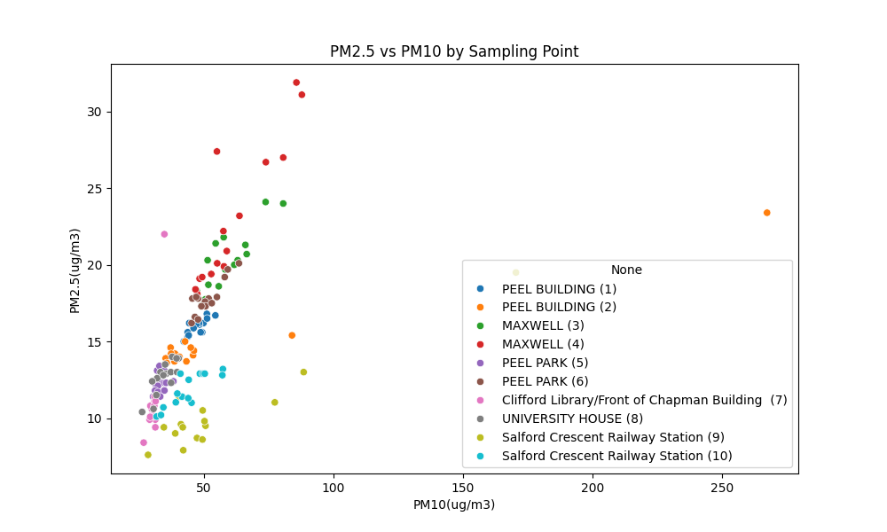
(PM10 and PM2.5 Scatterplot)
The plot reveals a clear linear correlation, where an increase in PM10 levels is consistently matched by a proportional increase in PM2.5. This relationship confirms our hypothesis that both pollutant fractions originate from the same primary sources. Specifically, the data highlights that PM2.5 constitutes a significant portion of the total PM10 mass, suggesting that the presence of PM10 emission sources serves as a direct indicator of elevated PM2.5 concentrations in these locations.
Taking the Maxwell locations for example identified as dot red and green for point 4 and 3 respectively in the above plot, we noticed that the red dot (Maxwell 4) has the highest pm10 readings and pm2.5 reading on average after careful look of it stated environmental surroundings, the most obvious source is possibly Industrialized AC vents and it proximity to driveway and walkway where dust from feets and combustion particles from vehicles can spread these matter


While the environmental observations at Maxwell 3 (green marker) provide clear evidence of localized sources, the recorded traffic volume of 138 vehicles serves as a primary driver for both PM10 and PM2.5 levels and also prescence of traffic lights where vehicles can decelerate and accelerate causing increase in these particles. Due to their lightweight nature, these particulates can easily disperse from the roadside into the surrounding campus environment, potentially impacting air quality in adjacent areas.
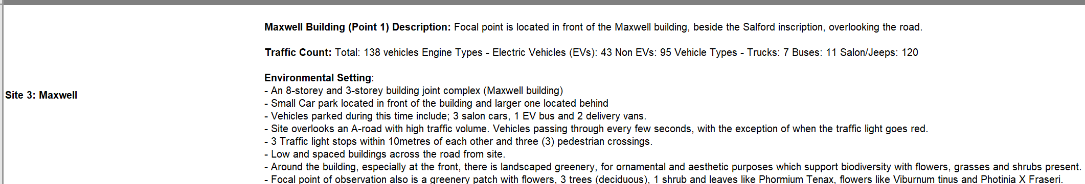

Outlier: The orange data point (Peel Building 2) is identified as an outlier, as its behavior deviates significantly from the general linear trend observed across other sites. Given the disproportionately high concentrations of both PM2.5 and PM10 at this location, this reading likely represents a transient 'pollution burst.' Based on site observations, this can be attributed to the location's function as a car park, where the cold start of a vehicle engine or the immediate proximity of cigarette smoke noted during the sampling period created a temporary, high intensity emission event.

Comparing these to the least PM2.5 environments (Salford Crescent Railway Station (9) & Clifford Library/Front of Chapman Building (7))

If we look at the Salford Crescent Railway Station, “the lemon dot” we see the lowest pollution levels. This is critical because it proves that high traffic volume alone doesn't guarantee high pollution. Unlike the Maxwell site, which is trapped by traffic lights and tall buildings, the station allows for 'busy movement.' This fluidity, combined with the absence of building exhaust vents, allows the air to remain significantly cleaner through natural atmospheric dispersion.

While the pink dot (Clifford Library/Front of Chapman Building 7) also shows minimal activities, compared to the observed environmental activities of the Maxwell sampling points where there is prescence primary sources of these particles.

- PM2.5 and Humidity Relationship Plots:
This relationship plot will help us understand how humidity affects the PM2.5 readings in the 150 observed rows
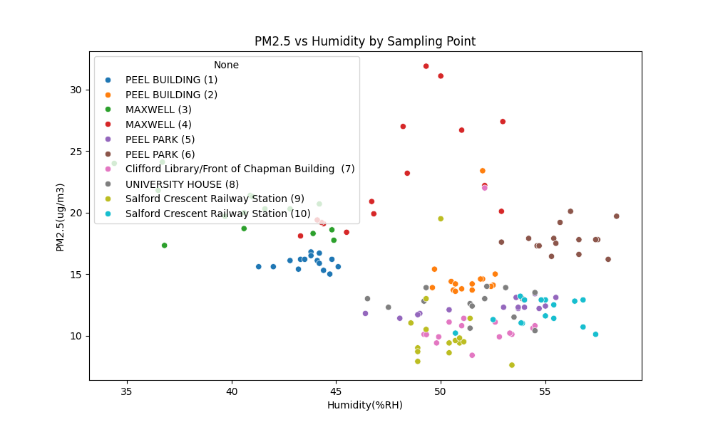
(PM2.5 vs Humidity Scatterplot)
The above shows a negative linear relationship where decrease in humidity leads to increase in PM2.5.
We can see the 2 sampling points (lemon and pink dots) with the least PM2.5 from the bar chart having high humidity and relatively low PM2.5, this approves our assumptions and also Maxwell 3 (green dot) having low humidity and high PM2.5 readings.

Outlier: Maxwell 4 being the location with the highest observed PM2.5 activities behaving very differently from the group calls for further location study as there is more datapoints with high humidity and high PM2.5 activities, indicating extreme source of PM10 and PM2.5 activities and also Peel Park 6 (brown dot) which is the third with the highest PM2.5 particles.
Note: This is the best case study for our follow on study
“EXPLORING NON-LINEAR AND THRESHOLD EFFECTS OF HUMIDITY ON PM2.5: A MICRO-ENVIRONMENTAL STUDY AT MAXWELL AND PEEL PARK BUILDING”

In conclusion, focusing on increasing humidity can help reduce Pm2.5 particles in the air.

- Humidity and Temperature Relationship Plots:
The purpose of this plot is to understand how temperature levels influences humidity counts in the atmosphere for each of the sampling points. Note: We used data from the M2000 series as that’s the machine with temperature monitoring
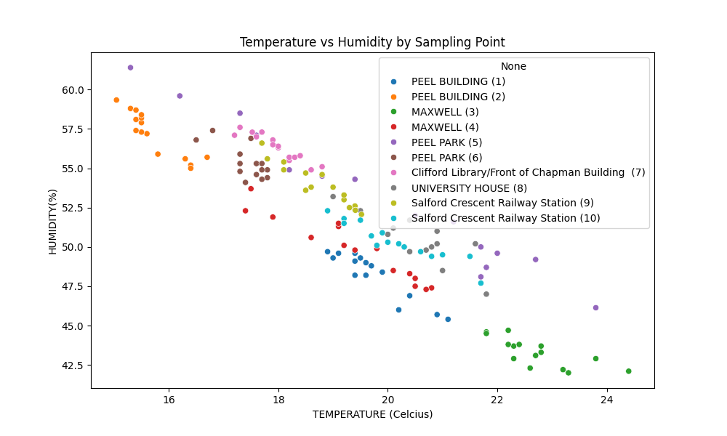
(Humidity vs Temperature Scatterplot)

In the observed plot, it is clear that this relationship is a negative linear one, where high temperature causes low humidity counts. Maxwell 3 (green dot) having the highest count of temperature explains why their humidity is low. Maxwell 4 (red dot) is also linear still stating temperature as a primary driver for humidity occurrence but this still doesn’t explain it high PM levels if humidity is high according to this chart.
Scattered occurrence of peel park 5 (purple dot) might be as a result of artificial temperature or heating, where building shadows or suddenheat wave might tamper with results

- Spatial Mapping:
The primary objective of this spatial mapping is to visualize the distribution of pollutants across the campus environment. By geolocating our sampling points, we can evaluate how physical site characteristics such as building density, road proximity, and ventilation infrastructure influence the dispersion and accumulation of Particulate Matter (PM).
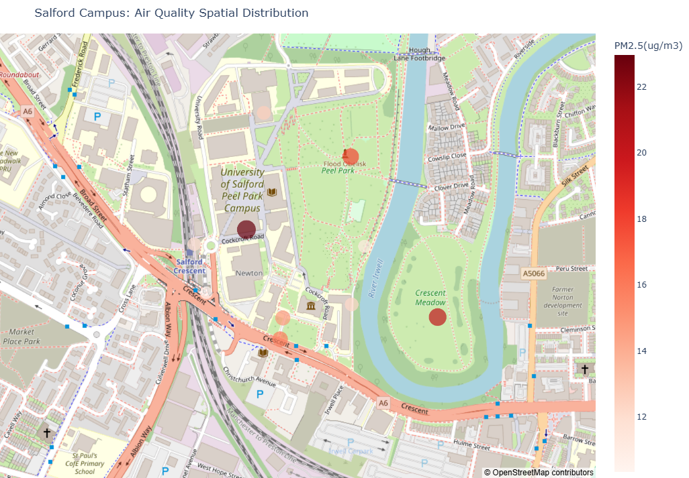
(Map Plot of locations and it PM level Activity)

The map above shows locations and the level of severeness of their PM levels, where the more darker the observed location, the better.
The darkest in the plot is maxwell 4, followed by maxwell 3.

LIMITATION OF STUDY

- Equipment Inconsistency
The primary limitation of this study involves the data quality harvested from the Temtop M2000 series monitors. Upon analysis, the Particulate Matter (PM) readings from these specific devices were found to be unrealistically low and inconsistent with the ambient conditions and traffic volumes observed.
The Discrepancy: While the AIRING-2000 series provided plausible data for urban roadside environments, the M2000 series appeared to have a lower sensitivity or a different calibration threshold, making its PM data unsuitable for high-confidence conclusions.

- Mitigation Strategy (Data Selection)
To maintain the integrity of the research, the study adopted a selective data integration strategy:

PM Analysis: The PM2.5 and PM10 findings were derived exclusively from the more reliable sensor sets to avoid skewing the spatial mapping results.

Environmental Metrics: The M2000 series was utilized only for its Temperature and Relative Humidity sensors. These values were found to be accurate and consistent across sampling points, providing the necessary environmental context for the correlation analysis.

- Impact on Research Design
This limitation highlights the challenges of using low-cost handheld sensors in field research. It underscores the necessity for sensor cross-calibration before data collection. This observation forms a core part of our recommendations for future studies: the standardization of equipment to ensure data homogeneity across all sampling locations.

RECOMMENDATIONS

- Targeted Traffic Control:
The data from this study consistently identified traffic density and vehicular behaviour as a primary driver of elevated PM2.5 and PM10 concentrations, particularly at the Maxwell 3 sampling point where 138 vehicles were recorded and the presence of traffic lights caused repeated vehicle deceleration and acceleration. It is therefore recommended that campus authorities and local councils introduce targeted traffic management interventions at identified hotspots. These could include the introduction of timed vehicle restrictions during peak periods, the redesign of road junctions to promote smoother traffic flow, and the enforcement of idling restriction zones near building entrances. Such measures would directly reduce primary combustion emissions at source, providing the most immediate and impactful improvement to localised air quality.

- Blue-Green Infrastructure:
Given the strong negative linear relationship identified between relative humidity and PM2.5 concentrations, the introduction of blue-green infrastructure across the campus and surrounding areas is strongly recommended. Vegetation such as trees, hedgerows, and planted buffer zones functions as a natural particulate filter, while also contributing to localised humidity regulation by increasing transpiration. Green corridors strategically placed along high-traffic routes and in the vicinity of Maxwell sampling points could act as physical and biological barriers to the dispersion of fine particles into adjacent areas. Similarly, blue infrastructure elements such as water features or misting systems could be explored in high-pollution micro-environments to artificially elevate ambient humidity, which this study has demonstrated to be associated with suppressed PM2.5 levels. These interventions are cost-effective, aesthetically beneficial, and aligned with broader urban sustainability goals.

- Standardisation of Monitoring Equipment:
One of the most significant methodological challenges encountered in this study was the incompatibility between data outputs from the AIRING-2000 and M2000 monitoring devices. The M2000 series produced PM readings that were unrealistically low and inconsistent with observed environmental conditions, necessitating the selective exclusion of its PM data from the core analysis. This compromised the ability to utilise all collected data and introduced uncertainty into the spatial comparisons. It is therefore strongly recommended that any future monitoring campaigns at the University of Salford standardise the equipment used across all sampling points. All devices should be of the same make and model, pre-calibrated against a reference instrument prior to deployment, and validated in parallel during at least one shared sampling session. Standardisation would ensure data homogeneity, improve statistical reliability, and allow for more robust cross-site comparisons.
- Extended Monitoring Duration Across Periods:
The current study was constrained to a relatively brief sampling window, which limits the temporal representativeness of the findings. Pollutant concentrations are known to vary significantly across different times of day (diurnal cycles), days of the week (weekday versus weekend traffic patterns), and seasons (temperature inversions in winter vs. increased dispersion in summer). The anomalous behaviour of Maxwell 4, which exhibited high PM2.5 levels even under elevated humidity conditions, may be partially attributable to short-term emission events captured within the narrow sampling window rather than consistent source activity. It is therefore recommended that future studies adopt an extended monitoring design spanning multiple time periods, including morning and evening peak hours, off-peak periods, and different seasons. This would provide a more accurate characterisation of chronic exposure risk and allow researchers to distinguish between transient pollution bursts and persistent hotspots, ultimately supporting more targeted and evidence-based air quality management strategies.

FOLLOW-ON STUDY

Rationale for Selecting This Follow-On Study:

The motivation for this follow-on study arises directly from one of the most compelling anomalies identified in the current dataset. Maxwell 4, the highest-pollution site across all sampling points, exhibited a pattern that directly contradicted the general trend established by the humidity-PM2.5 negative linear relationship: it recorded persistently elevated PM2.5 and PM10 concentrations even under relatively high humidity conditions. This behaviour, which was further underscored by its classification as an outlier in the PM2.5 vs. humidity scatter plot, suggests that the site is subject to emission sources of sufficient intensity to override the suppressive effect of atmospheric moisture on particulate matter.
Peel Park Building 6 was also identified as the third highest PM2.5 location and similarly exhibited scattered behaviour in the humidity-temperature relationship plot, potentially indicating exposure to artificial heat sources or localised environmental disruption. Together, these two sites represent micro-environments where the standard linear relationships break down, and where threshold or non-linear dynamics may be operating. Understanding these dynamics is not merely of academic interest; it is essential for identifying the true drivers of chronic PM2.5 exposure and designing effective, targeted interventions in a campus environment that is shared by a large student and staff population.
The proposed follow-on study is therefore titled: "Exploring Non-Linear and Threshold Effects of Humidity on PM2.5: A Micro-Environmental Study at Maxwell and Peel Park Building."

Aim and Objectives:
Aim: To investigate the non-linear and threshold-dependent relationship between relative humidity and PM2.5 concentrations at the Maxwell 4 and Peel Park Building 6 micro-environments, with the purpose of identifying the primary emission sources and quantifying their relative contributions under varying meteorological conditions.

Objectives:
- To conduct intensive, extended sampling at Maxwell 4 and Peel Park Building 6 across multiple time periods, including morning peak, afternoon off-peak, and evening peak windows, over a minimum of four weeks.

- To characterise the diurnal and seasonal variation in PM2.5 and PM10 concentrations at both sites, and to determine whether the observed anomalous behaviour is consistent or episodic in nature.

- To apply segmented regression and piecewise modelling techniques to identify humidity thresholds above and below which the relationship with PM2.5 changes in character or direction.

- To integrate source-apportionment analysis by collecting qualitative field data on proximate emission events (vehicle cold starts, AC vent activity, cigarette smoke, construction activity) timed alongside instrument readings.

- To compare findings against a control site (e.g., Clifford Library / Front of Chapman Building) where the standard linear relationship was well-established, enabling direct attribution of variance to micro-environmental factors.

Methodology and Methodologies (with Justification and Recognition of Limitations):

Intensive Fixed-Site Continuous Monitoring:
Unlike the current study, which employed a roving sampling design across ten locations, the follow-on study will adopt a fixed-site, high-frequency monitoring design at the two target locations. Standardised, cross-calibrated instruments of the same make and model will be deployed continuously at Maxwell 4 and Peel Park Building 6 for a minimum of four consecutive weeks. This approach is justified by the need to capture diurnal cycles, transient pollution bursts, and the influence of changing meteorological conditions on PM dynamics at these specific hotspots. The limitation of this approach is that it sacrifices spatial breadth for temporal depth, and findings will be site-specific rather than broadly generalisable to the full campus environment.

Meteorological Co-Variate Integration:
A dedicated portable weather station will be co-located at each monitoring site to capture wind speed, wind direction, temperature, and relative humidity at one-minute intervals throughout the study. In the current study, the absence of wind data was a notable gap, as wind speed and direction are known to play a critical role in the dispersion and accumulation of particulate matter. The integration of a fuller meteorological dataset into a multivariate regression framework will allow the study to disaggregate the independent contributions of humidity, temperature, and wind to observed PM2.5 concentrations, providing a significantly more nuanced and defensible interpretation of the results. The limitation here is the cost and logistical complexity of deploying and maintaining a dedicated weather station over a four-week period in a busy urban campus environment.

